实验编号：08 **四川师大《IOS高级开发技术》实验报告 2018** 年**11**月 **7** 日

**计算机科学学院** 2016 级4班 实验名称： 作业八 _

姓名：_邹琳_ 学号：__2016110458_ 指导老师：李贵洋 实验成绩:_____

**实验_8_ ________作业八___________**

1. 实验目的及要求

1、实验目的

1. 掌握TextField和Delegate、Notification的使用；
2. 掌握表视图TableView以及Datasource、Delegate等的使用；

2、实验要求

1. 认真填写实验报告，要求附加部分运行界面和主要代码；
2. 对设计好的程序，检查输出是否符合预期，如有错请分析错误原因并解决；
3. 实验内容
4. 将之前作业实现的Person 类和子类导入新项目，新建多个 Student 和 Teacher 对象并放入一数组中；
5. 数组排序后采用 TableView 的形式显示所有Student和Teacher对象的信息，要求每一个对象一个Cell，同时学生和教师显示不同的信息，选择一个Cell 后给出选择反馈；
6. 修改界面，增加添加新学生的部分(键盘要正确显示和消失)，要求实现TableView的增删改;

说明：键盘显示消失需要基于Notification 实现自适应键盘的界面布局;注册KeyboardDidShow和KeyBoardWillHide通知，并处理相应的action，进行界面的布局调整；

1. 实验主要流程、基本操作或核心代码、算法片段（该部分如不够填写，请另加附页）

//

// Person.swift

// eight

//

// Created by student on 2018/11/22.

// Copyright © 2018年 2016110458. All rights reserved.

//

import Foundation

enum Gender:Int{

case male,female,unknow

static func >(lhs: Gender, rhs: Gender) -> Bool {

return lhs.rawValue < rhs.rawValue

}

}

class Person {

var Name:String

var age:Int

var gender:Gender

init(Name:String, age:Int, gender:Gender){

self.Name=Name

self.age=age

self.gender=gender

}

convenience init (name:String){

self.init(Name:name,age:21, gender: Gender.female)

}

var description: String {

return "Name: \(Name), age: \(age), gender: \(gender)"

}

static func ==(p1:Person,p2:Person)->Bool{

return p1.Name==p2.Name

}

static func != (p1:Person,p2:Person)->Bool{

return p1.Name != p2.Name

}

}

class Student:Person{

var stuNo:String

init(Name:String, age:Int, gender:Gender,stuNo:String){

self.stuNo=stuNo

super.init(Name:Name,age:age, gender:gender)

}

convenience init (name:String,nom:String){

self.init(Name:name,age:20, gender: Gender.female,stuNo:nom)

}

override var description:String {

return super.description + " stuNo:\(stuNo)"

}

}

class Teacher:Person{

var title:String

init(Name:String, age:Int, gender:Gender,title:String){

self.title=title

super.init(Name:Name, age:age, gender:gender)

}

convenience init (name:String,nom:String){

self.init(Name:name,age:44, gender: Gender.male,title:nom)

}

override var description:String {

return super.description + " title:\(title)"

}

}

/******************************************************************/

//

// PersonCell.swift

// eight

//

// Created by student on 2018/11/22.

// Copyright © 2018年 2016110458. All rights reserved.

//

import UIKit

class PersonCell: UITableViewCell {

@IBOutlet weak var other: UILabel!

@IBOutlet weak var gender: UILabel!

@IBOutlet weak var age: UILabel!

@IBOutlet weak var name: UILabel!

override func awakeFromNib() {

super.awakeFromNib()

// Initialization code

}

override func setSelected(_ selected: Bool, animated: Bool) {

super.setSelected(selected, animated: animated)

// Configure the view for the selected state

}

}

/*****************************************************************/

//

// ViewController.swift

// eight

//

// Created by student on 2018/11/22.

// Copyright © 2018年 2016110458. All rights reserved.

//

import UIKit

class ViewController: UIViewController,UITableViewDelegate,UITableViewDataSource {

@IBOutlet weak var chooseLabel: UILabel!

@IBOutlet weak var table: UITableView!

var alert : UIAlertController!

var students = [Student]()

var teachers = [Teacher]()

var tableTitle = ["teacher","student"]

//单元格数量

func tableView(_ tableView: UITableView, numberOfRowsInSection section: Int) -> Int {

if section == 0{

return teachers.count

}

else{

return students.count

}

}

//显示数据

func tableView(_ tableView: UITableView, cellForRowAt indexPath: IndexPath) -> UITableViewCell {

let ident = tableTitle[indexPath.section]

var cell:PersonCell!

cell = tableView.dequeueReusableCell(withIdentifier: ident ) as! PersonCell

switch ident {

case "student":

let stu = students[indexPath.row]

cell.name.text = stu.Name

cell.age.text = "\(stu.age)"

cell.gender.text = "\(stu.gender)"

cell.other.text = stu.stuNo

case "teacher":

let ter = teachers[indexPath.row]

cell.name.text = ter.Name

cell.age.text = "\(ter.age)"

cell.gender.text = "\(ter.gender)"

cell.other.text = ter.title

default:

break

}

return cell

}

//初始化信息数据

override func viewDidLoad() {

super.viewDidLoad()

// Do any additional setup after loading the view, typically from a nib.

students.append(Student(Name: "张三1", age: 21, gender: Gender.female, stuNo: "201601"))

students.append(Student(Name: "张三2", age: 20, gender: Gender.male, stuNo: "201602"))

students.append(Student(Name: "张三3", age: 21, gender: Gender.female, stuNo: "201603"))

teachers.append(Teacher(Name: "李四1", age: 43, gender: Gender.male, title: "数学"))

teachers.append(Teacher(Name: "李四2", age: 40, gender: Gender.male, title: "英语"))

teachers.append(Teacher(Name: "李四3", age: 40, gender: Gender.female, title: "语文"))

students.sort(by: { (s1,s2) -> Bool in

return s1.age < s2.age

})

teachers.sort(by: { (t1,t2) -> Bool in

return t1.age < t2.age

})

}

//指定section，返回类型

func numberOfSections(in tableView: UITableView) -> Int {

return tableTitle.count

}

//给cell加名字

func tableView(_ tableView: UITableView, titleForHeaderInSection section: Int) -> String? {

return tableTitle[section]

}

//每个单元格的高度

func tableView(_ tableView: UITableView, heightForRowAt indexPath: IndexPath) -> CGFloat {

return 80

}

//编辑信息

@IBAction func editclick(_ sender: Any) {

table.isEditing = !table.isEditing

}

//删除信息

func tableView(_ tableView: UITableView, commit editingStyle: UITableViewCellEditingStyle, forRowAt indexPath: IndexPath) {

if editingStyle == .delete{

if indexPath.section == 0{

teachers.remove(at: indexPath.row)

}else{

students.remove(at: indexPath.row)

}

table.deleteRows(at: [indexPath], with: .fade)

}

}

//使顺序可变

func tableView(_ tableView: UITableView, canMoveRowAt indexPath: IndexPath) -> Bool {

return true

}

func tableView(_ tableView: UITableView, moveRowAt sourceIndexPath: IndexPath, to destinationIndexPath: IndexPath) {

let name = students.remove(at: sourceIndexPath.row)

students.insert(name, at: destinationIndexPath.row)

}

//添加学生弹出框，用alert实现

@IBAction func addclick(_ sender: Any) {

alert = UIAlertController(title: "add student information", message: nil, preferredStyle: .alert)

alert.addAction(UIAlertAction(title:"Add",style: .default,handler: {

(action) in

self.add()

}))

alert.addAction(UIAlertAction(title:"Cancel",style: .cancel,handler:nil))

alert.addTextField {(textField) in

textField.placeholder = "name"

}

alert.addTextField {(textField) in

textField.placeholder = "age"

}

alert.addTextField {(textField) in

textField.placeholder = "gender"

}

alert.addTextField {(textField) in

textField.placeholder = "stuNumber"

}

present(alert, animated: true, completion: nil)

}

//添加

func add(){

let name = alert.textFields![0].text!

let age = Int(alert.textFields![1].text!)

let num = alert.textFields![3].text!

let gender:Gender

switch alert.textFields![2].text! {

case "male":

gender = .male

case "female":

gender = .female

default:

gender = .unknow

}

let student = Student(Name:name,age:age!,gender:gender,stuNo:num)

students.append(student)

table.reloadData()

}

//选择提醒

func tableView(_ tableView: UITableView, didSelectRowAt indexPath: IndexPath) {

chooseLabel.text = "You choose: \(students[indexPath.row])"

}

}

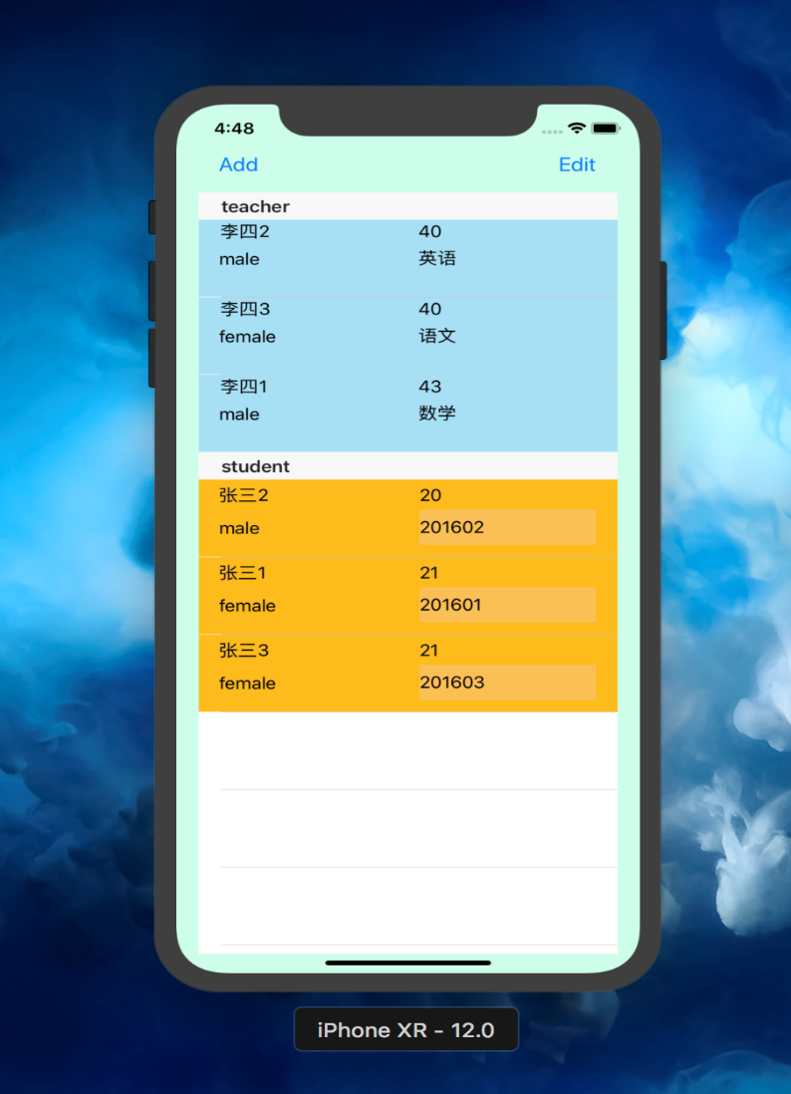 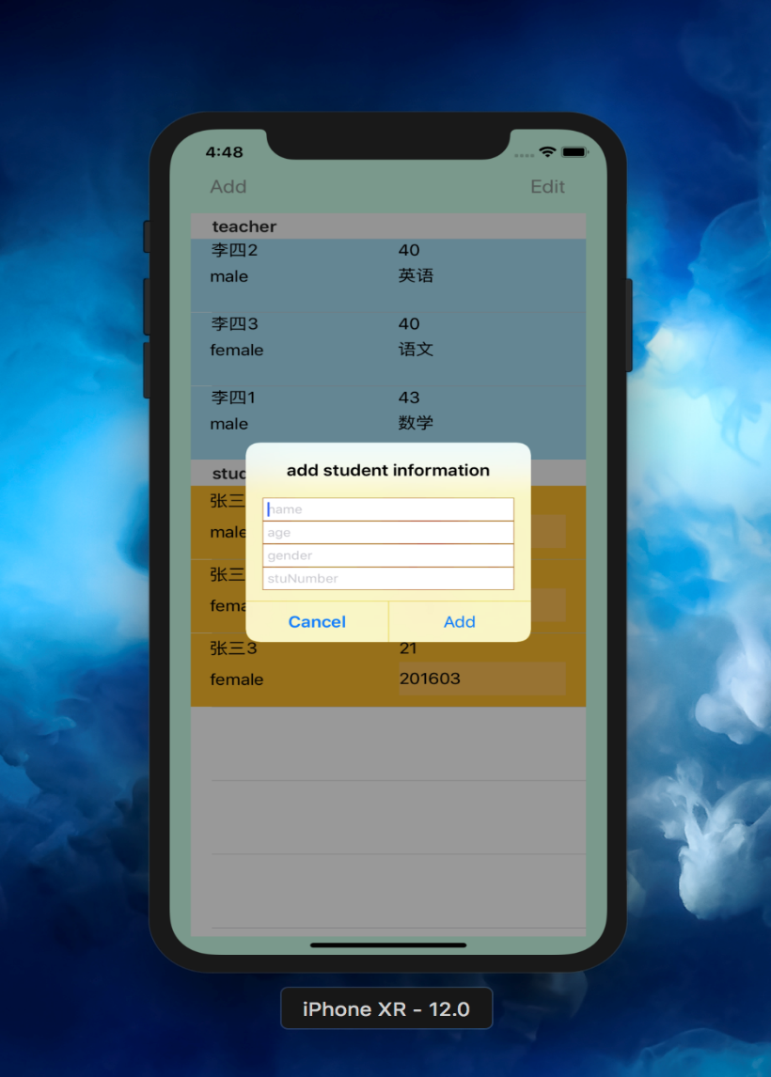

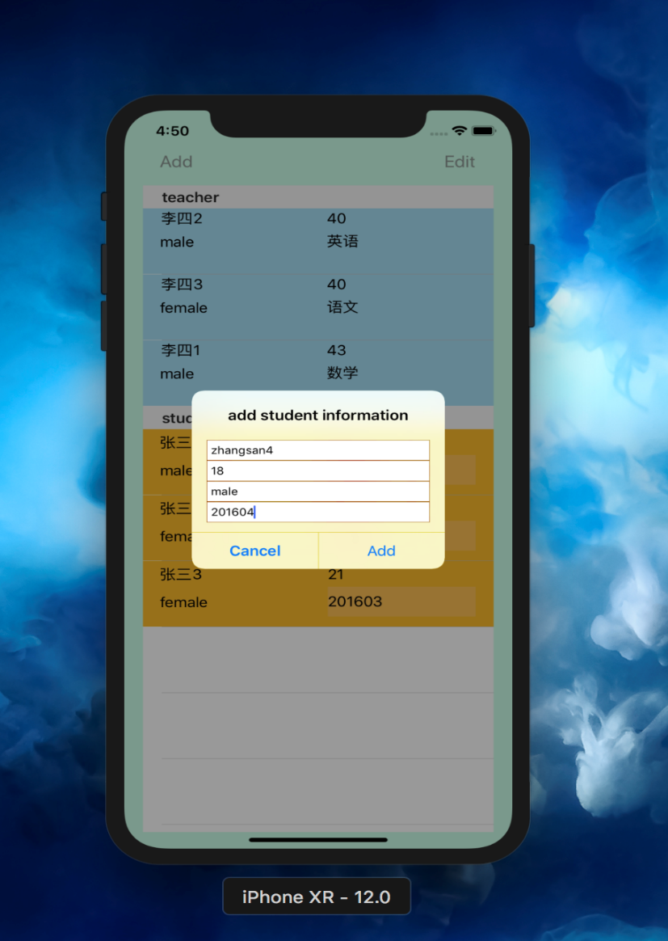 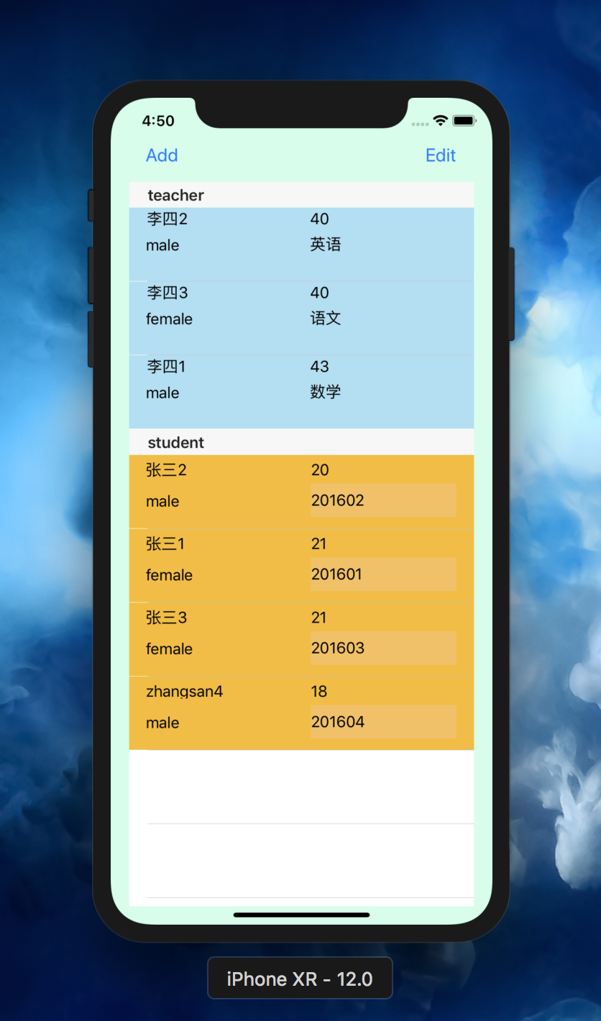

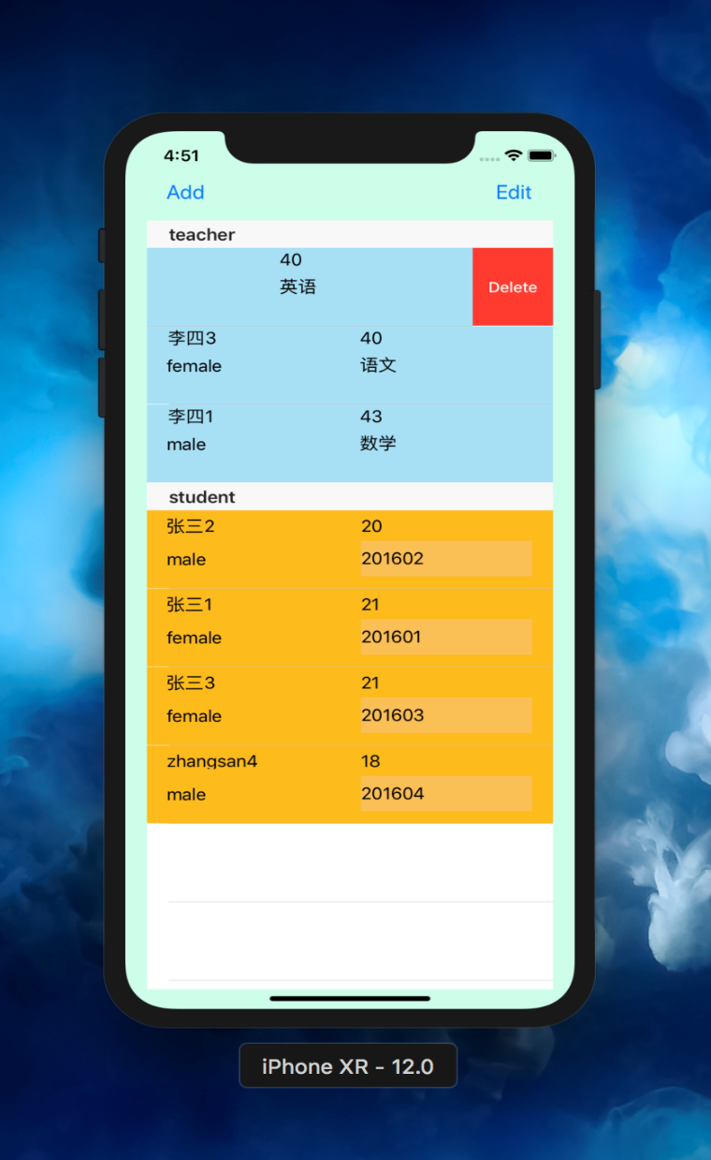 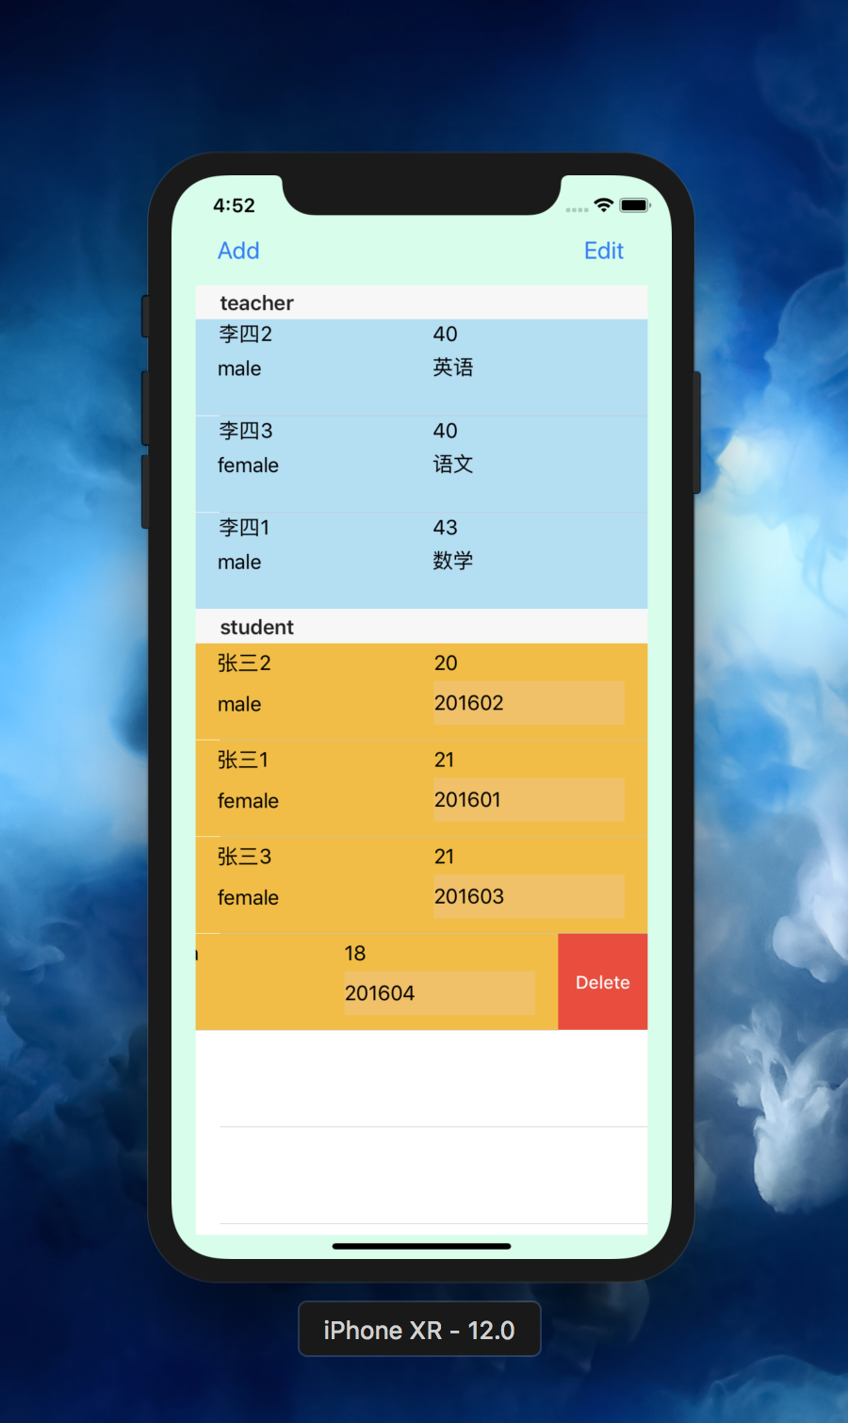

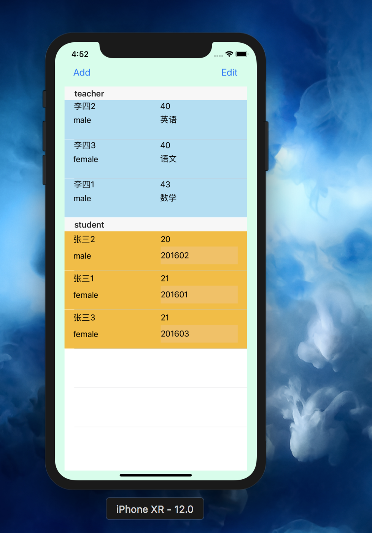 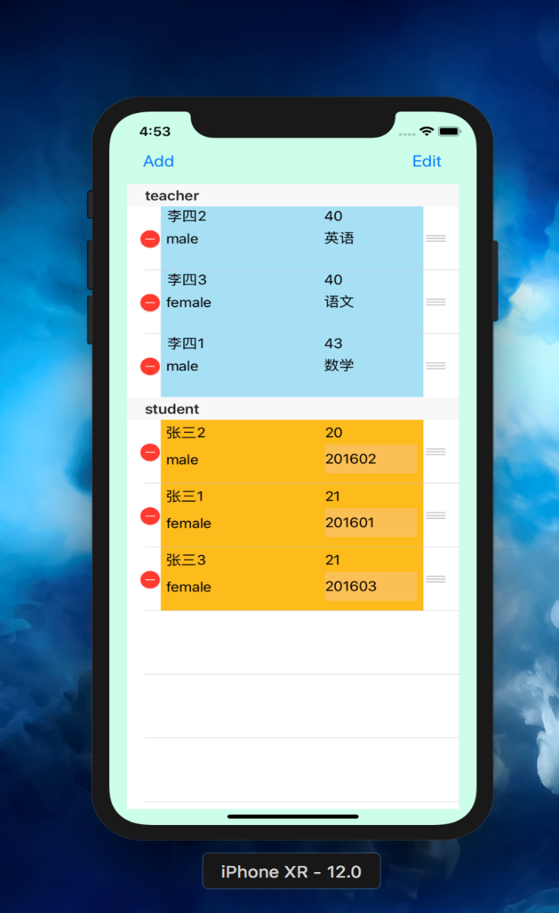

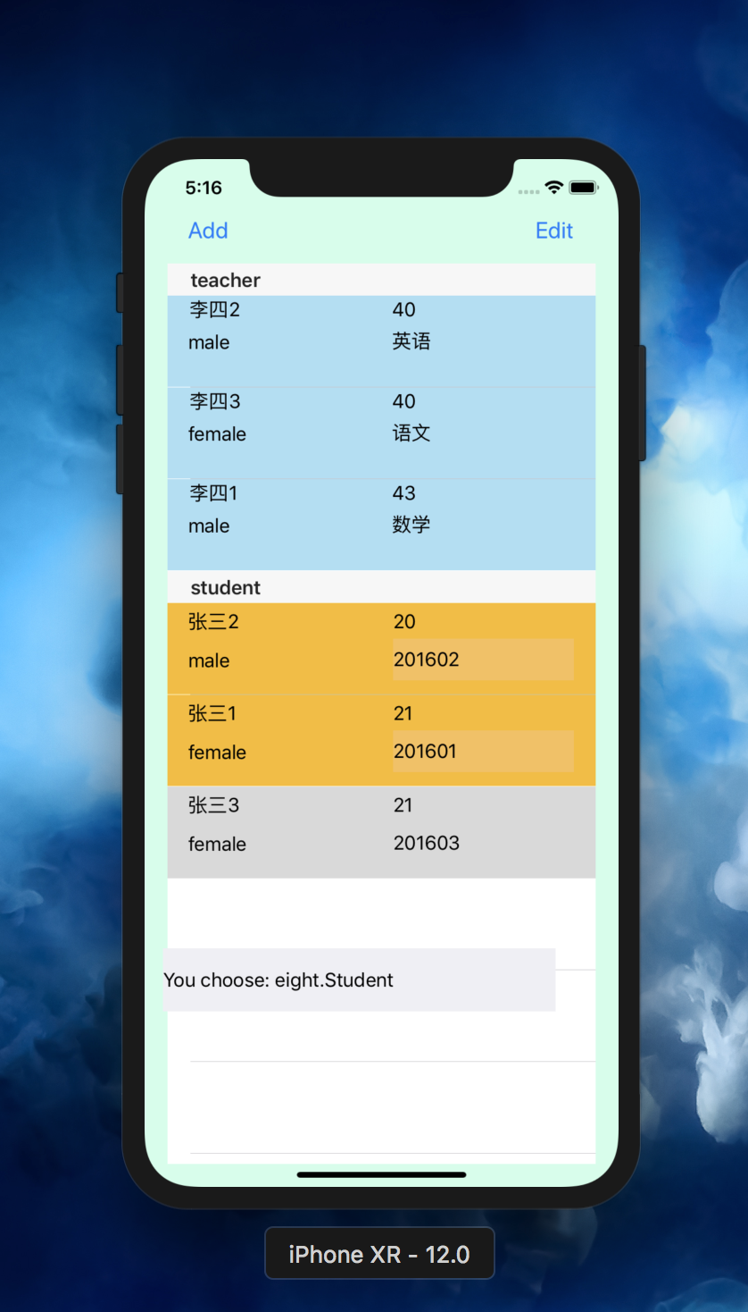

1. 实验结果的分析与评价（该部分如不够填写，请另加附页）

注：实验成绩等级分为（90－100分）优，（80－89分）良，(70-79分)中，（60－69分）及格，（59分）不及格。